***AIDS MICROPROCESSOR LAB S21 BATCH (2023-24)***

***Experiment 10 Title: Assembly language programming to display a message in different colour with blinking.***

***Name of student: Meet Raut Class Roll Number: 2201084***

***Date of Performance: 18/03/2024***

***Batch: S2-1 Timing: 3:00-5:00 Date of Submission: 18/03/2024***

***Assembly language code***

*DATA_SEG SEGMENT*

*ROW DB 5*

*COL DB 15*

*STRS DB '084_MEET'*

*DATA_SEG ENDS*

*CODE_SEG SEGMENT*

*ASSUME CS:CODE_SEG, DS:DATA_SEG, ES: DATA_SEG*

*START:*

*MOV AX,DATA_SEG*

*MOV DS,AX*

*MOV ES,AX #initialise data segment*

*MOV AL,1 #using service 01 to assign char attributes in bl*

*MOV BH,0 #setting page to 0*

*MOV BL,094H #9=1001 (blue) 4=0100 (red)*

*MOV CX,10 # no. of char in string*

*MOV DH,ROW #setting row number*

*MOV DL,COL #setting column number*

*MOV BP,OFFSET STRS #setting pounter to print the string*

*MOV AH,13H #using service 13h to print string*

*INT 10H #interrupt called*

*MOV BL,0C9H #c=1101(red) 9=1001(light blue)*

*MOV CX,10 #number of char in string*

*MOV DH,07 #setting row number*

*MOV DL,COL #setting col number*

*MOV BP,OFFSET STRS #setting pointerto print string*

*MOV AH,13H #using service 13 to print string*

*INT 10H #interrupt called*

*MOV AH,4CH*

*INT 21H*

*CODE_SEG ENDS*

*END START*

*Result:*

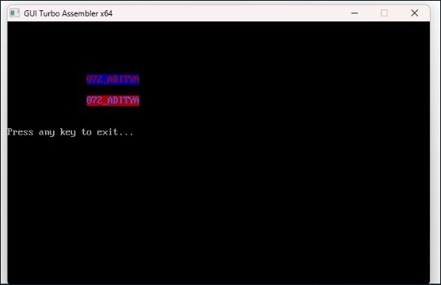

*CONCLUSION: LO 2, LO 3 mapped.*

***---------------------------------*****************************-----------------------------------***